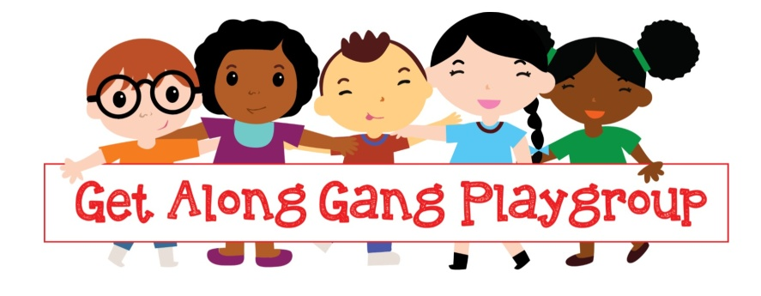
Get Along Gang Playgroup
Concorde Centre
Kingsmead Way
London E9 5PP
Tel: 07944407889
getalonggangpreschool@gmail.com

GET ALONG GANG PLAYGROUP APPLICATION FORM

Proof of DOB seen by …………………….. Date of Registration: …………………

Name and age of child under five for whom admission is desired:
First name | Surname | Gender | Date of birth
  M | F

 |  | Day session | Per week
 | Monday | Tuesday | Wednesday | Thursday | Friday
AM (8.45am-
11-45am)
PM (11.45am-14.45pm)

When would you like your child to start? ……………………………………………

Name of the parent or guardian in full | Home address | Tel no/mobile no/email address
 | Post code: | Tel No:  Mobile No:  Email:
 | Post code: | Tel No:  Mobile No:  Email:

Child’s first language ……………………………………………………………………………………….
Child’s Religion: ……………………………………………………………………....................................
Do you have concern around your child’s development? Yes No , if yes please give more details. ………………………………………………………………………………………………………………
………………………………………………………………………………………………………………

Are you interested to apply 2 years old free childcare funded places: Yes No
Do you have 2 years funding code; …………………. if not you can check your eligibility at;

https://education.hackney.gov.uk/content/fifteen-hours-free-childcare-some-2-year-olds?guidebook=182

If Yes Please tell us what benefits are you receiving …………...………………………………………………............................................
We can help you to check your eligibility to find out if you are eligible to 2 years old free childcare places.

If your child is 3 or 4 years old your child will be eligible for Free 15 hours childcare education and if you are working you may be eligible for additional 15 hours. You can check your eligibility for 30 hours free childcare education on the link below by following the steps.
https://www.gov.uk/30-hours-free-childcare

if you are eligible for 30 hours free-childcare please provide the eligibility code : …………………………

Are you or your partner working more than 16 hours per week? Yes No | Are you or your partner in Education?  Yes No | Are you a lone parent household?  Yes No

Ethnicity of the Child

White English |  | Greek/Greek Cypriot |  | White and Black Caribbean |  | Caribbean |  | Other Black African
White Scottish |  | Turkish |  | White and Black African |  | Angolan |  | Chinese
White Welsh |  | Turkish Cypriot |  | White and Asian |  | Congolese |  | Afghan
White Cornish |  | White Eastern European |  | Any Other Mixed Background |  | Ghanaian |  | Kurdish
Any Other White British |  | White Western European |  | Indian |  | Nigerian |  | Latin/South/  Central American
White Irish |  | White Other |  | Pakistani |  | Sierra Leonean |  | Vietnamese
Traveller of Irish Heritage |  | Gypsy/Roma |  | Bangladeshi |  | Somali |  | Any Other Group
Albanian |  | Orthodox Jewish |  | Any other Asian background* |  | Sudanese |  | Refused

Is there anything else we should know about the child (e.g. health, special needs, developmental delay, cultural requirements, allergy etc)?
……………………………………………………………………………………………………………….
……………………………………………………………………………………………………………….

